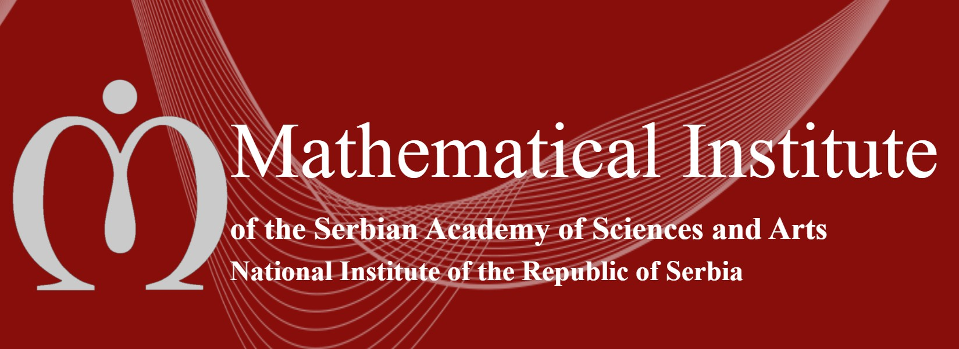

3rd CORE GROUP MEETING (CGM-2021) DIGFORASP COST ACTION 17124

Departamento de Matemáticas
Mathematical Institute of the Serbian Academy of Sciences and Arts. Belgrade, Serbia
September 2nd – 4th

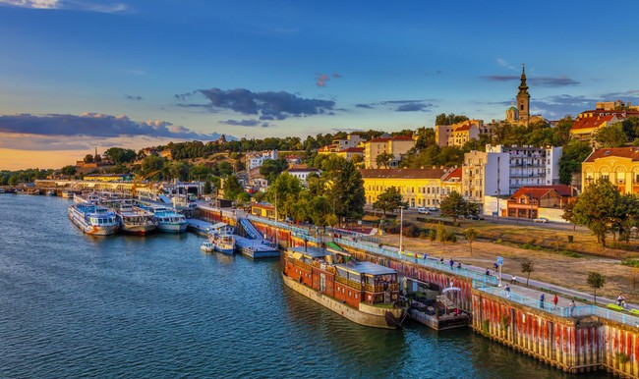

THURSDAY 2nd
10:00–12:00 | Participants arrive in Belgrade at the Hotel Majestic
12:00–13:00 | Welcome: gathering of participants in the hotel lounge
13:00–14:30 | Working lunch in nearby restaurant
14:30–14:45 | Opening at room MISANU, Kneza Mihaila 36, third floor, 301f.  Jesús Medina (Action Chair), Andreja Łepavcevic (Local Organizer and WG6 Leader)
14:45–15:00 | Welcome and presentation of National Center for Cyber Security and Privacy (MISANU).  Dr. Miodrag Mihaljevic, Vicedirector of MISANU
15:00–18:30 | Working and Budget Plan (W&BP) for the 3rd and 4th Grant Periods.  Session 1
 | 15:00–16:00 | Status of the budget and new events during the 3rd Grant Period
 | 16:00–16:30 | Coffee break
 | 16:30–17:30 | Preparation of the W&BP for the last GP
 | 17:30–18:00 | Training School
 | 18:00–18:30 | Dissemination meetings
20:00 | Dinner

FRIDAY 3rd
9:00–13:00 | Presentations and discussions in conference room. Session 2
 | 9:00–10:30 | Achievements and new goals of WGs 1–3
 | 10:30–11:00 | Coffee break
 | 11:00–12:00 | Achievements and new goals of WGs 4–5
 | 12:00–13:00 | Current situation and planning of WGs 6–8
13:00–14:30 | Lunch
15:00–18:00 | Discussions on further directions on networking and research
20:00 | Dinner

SATURDAY 4th
9:00–13:00 | Presentations and discussions in conference room. Session 3
 | 9:00–9:30 | STSM dissemination
 | 9:30–10:00 | ITC Conference Grants
 | 10:00–11:00 | Communication strategy
 | 11:00–11:30 | Coffee break
 | 11:30–13:00 | Final W&BP for the 4th Grant Period
13:00–14:30 | Lunch
14:30–19:00 | Tourist visit to Belgrade
19:00 | End of the meeting

