Human-computer interaction,
security, and forensics

dr Aleksandar Jevremovic,
COST Action 17124 - Digital forensics: evidence analysis via intelligent systems and practices

Few words about me...
Full professor at the Faculty of Informatics and Computing, Singidunum University, Belgrade
Serbian representative at the TC on Human–Computer Interaction of the IFIP Visiting scholar at Cyprus Interaction Lab, Limassol, Cyprus
Guest lecturer at Harvard University, Cambridge, MA, USA Leader of the CASPER project (NGI TRUST / Horizon 2020)
Researcher at School of Electrical Engineering, University of Belgrade, Serbia

CASPER Project
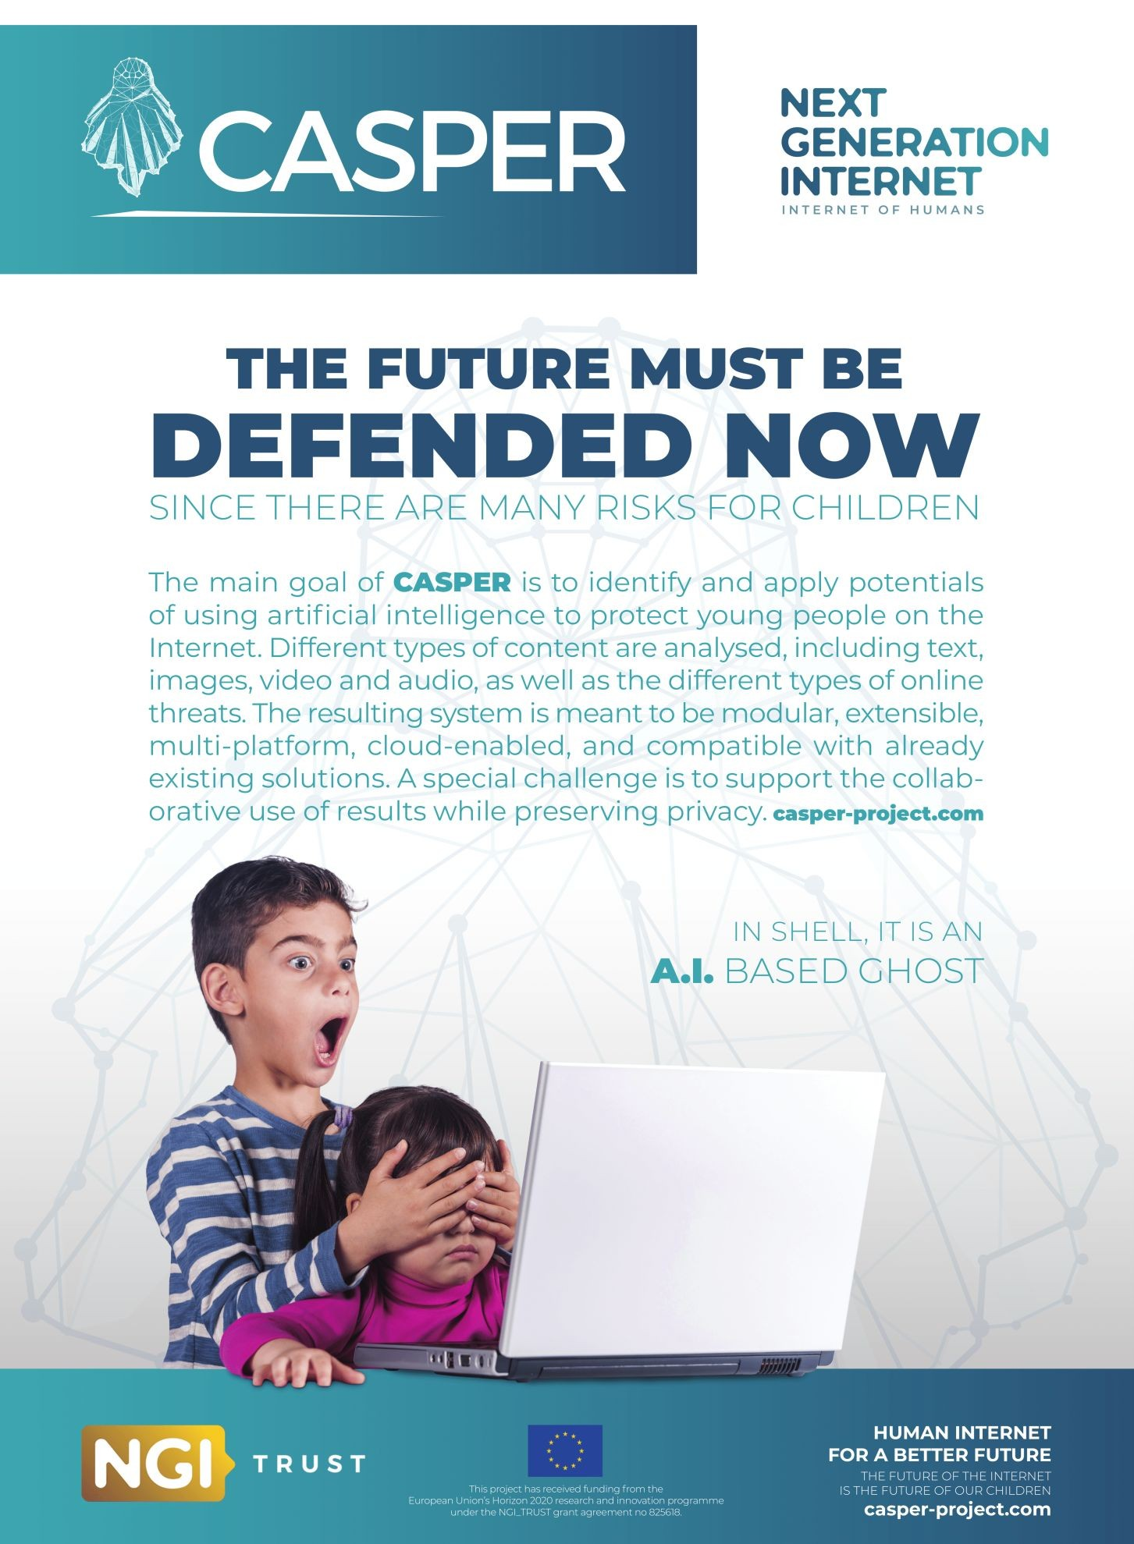

CASPER Architecture
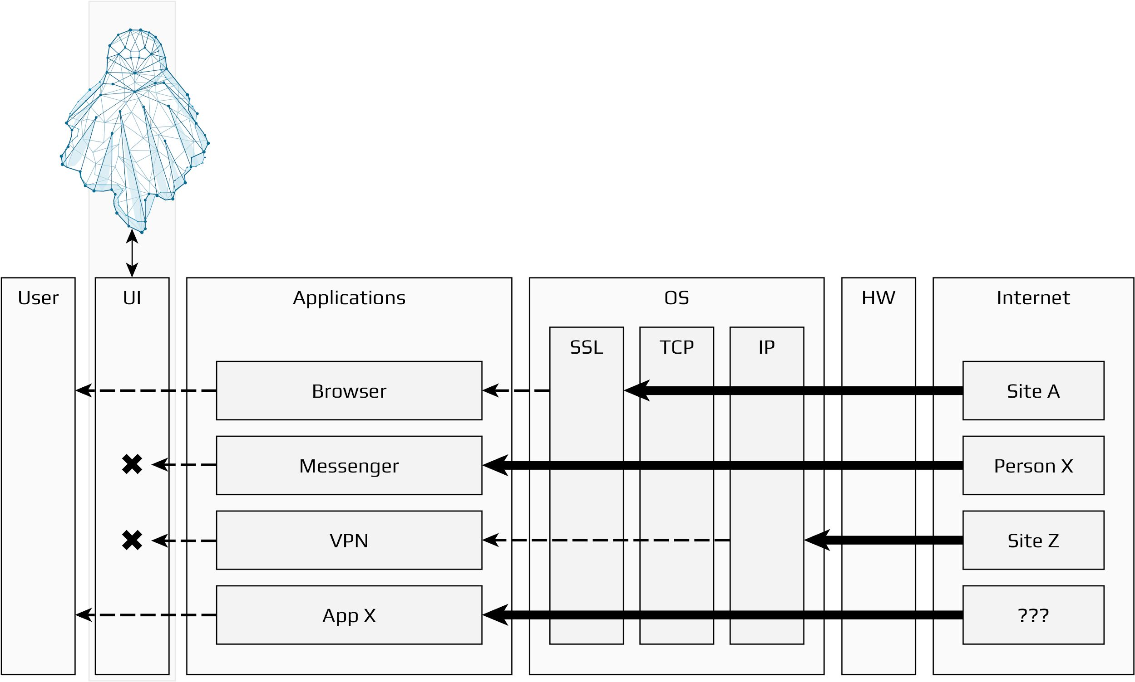

CASPER in action (example)

CASPER Architecture
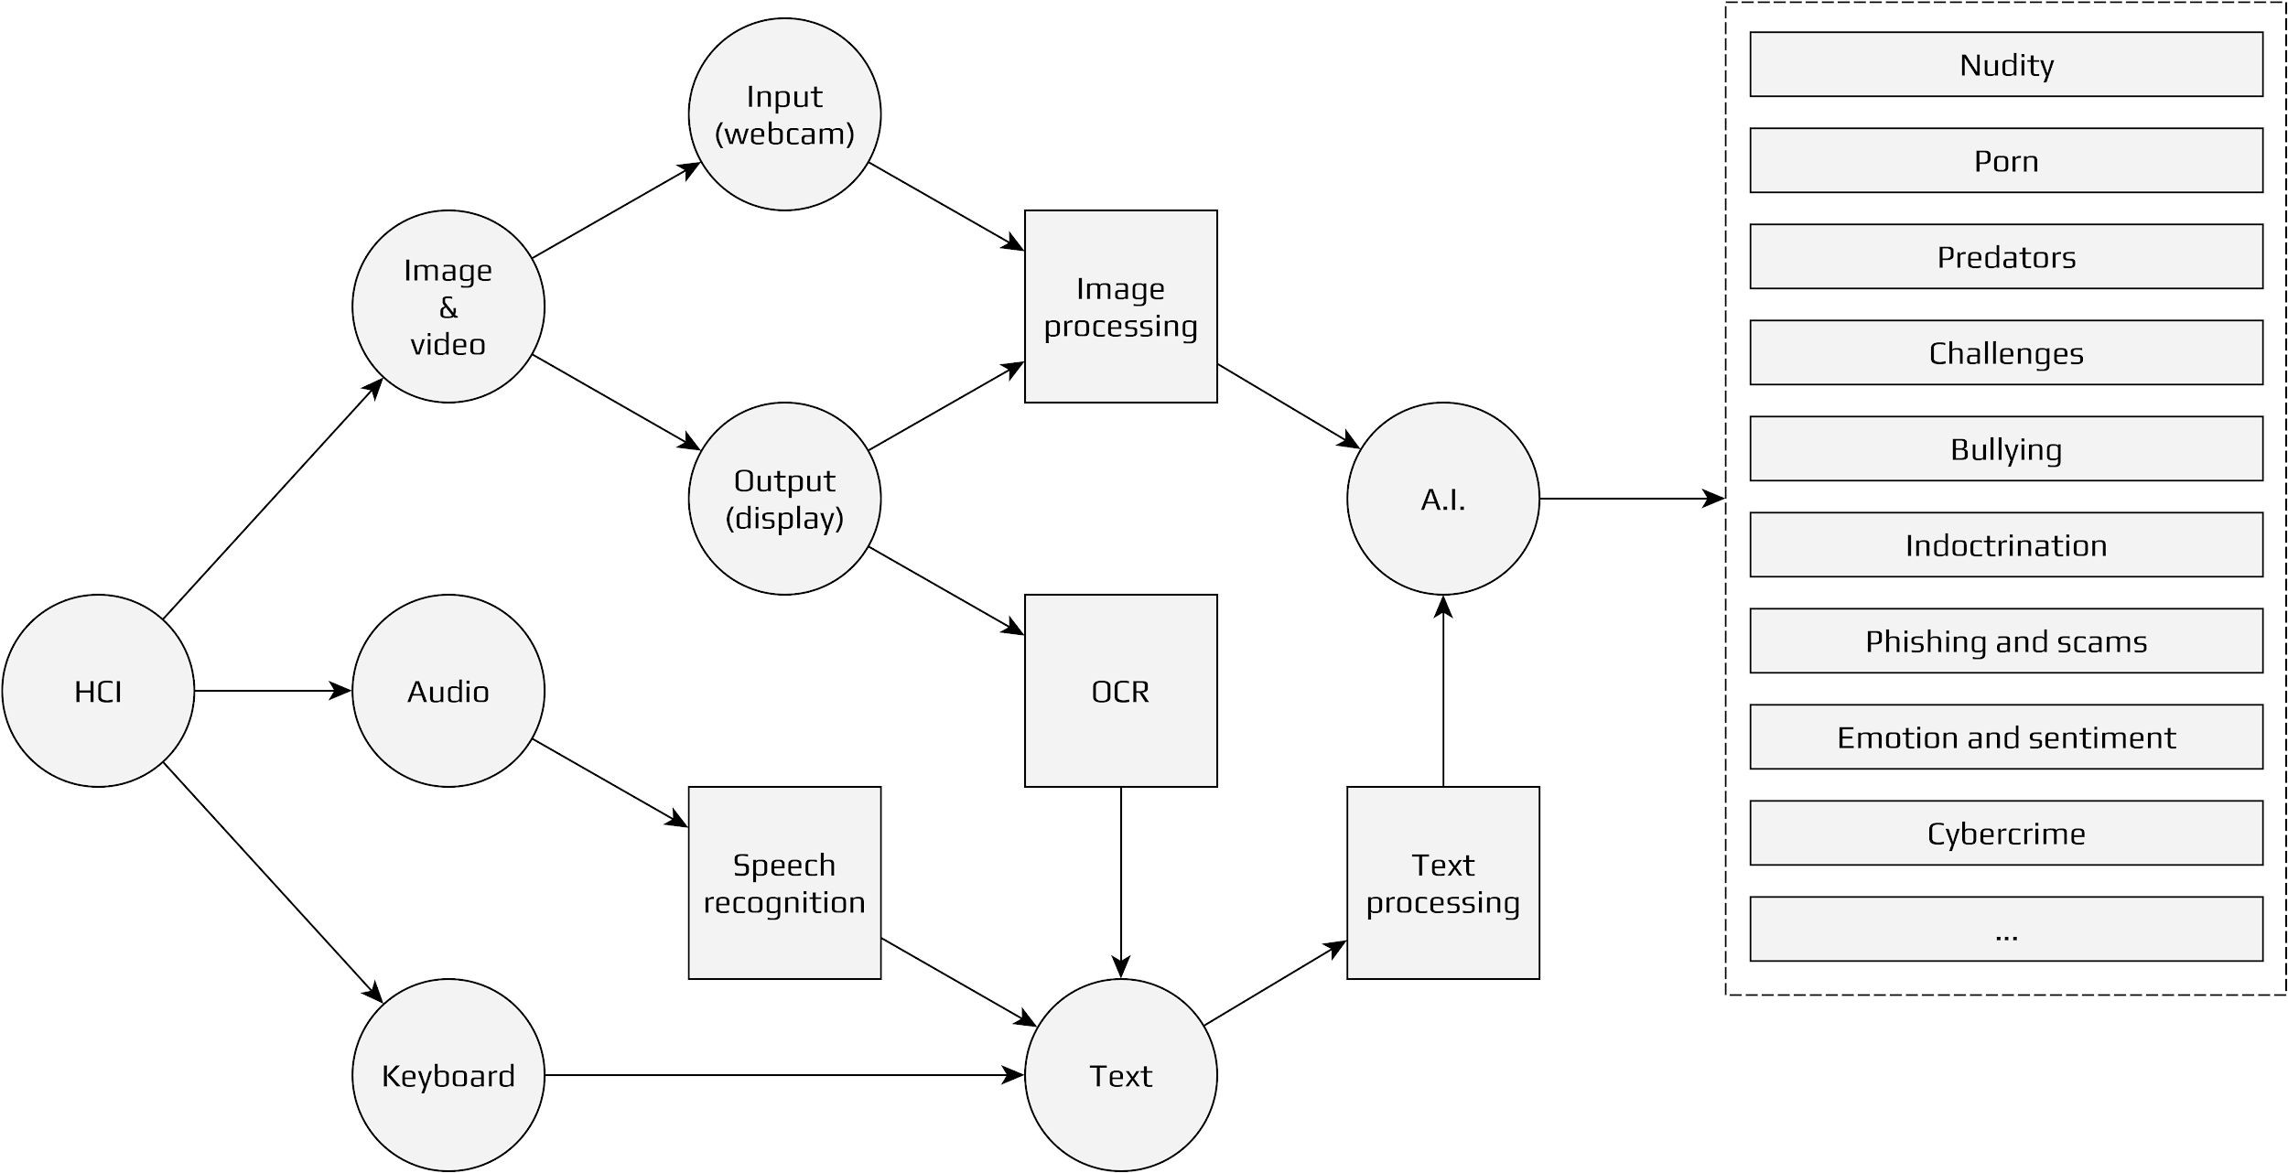

Digital forensics
Preserving evidence (e.g. communication with predators) Protecting privacy
Digital signature and asymmetric encryption Parents/supervisors, authorities

Solutions
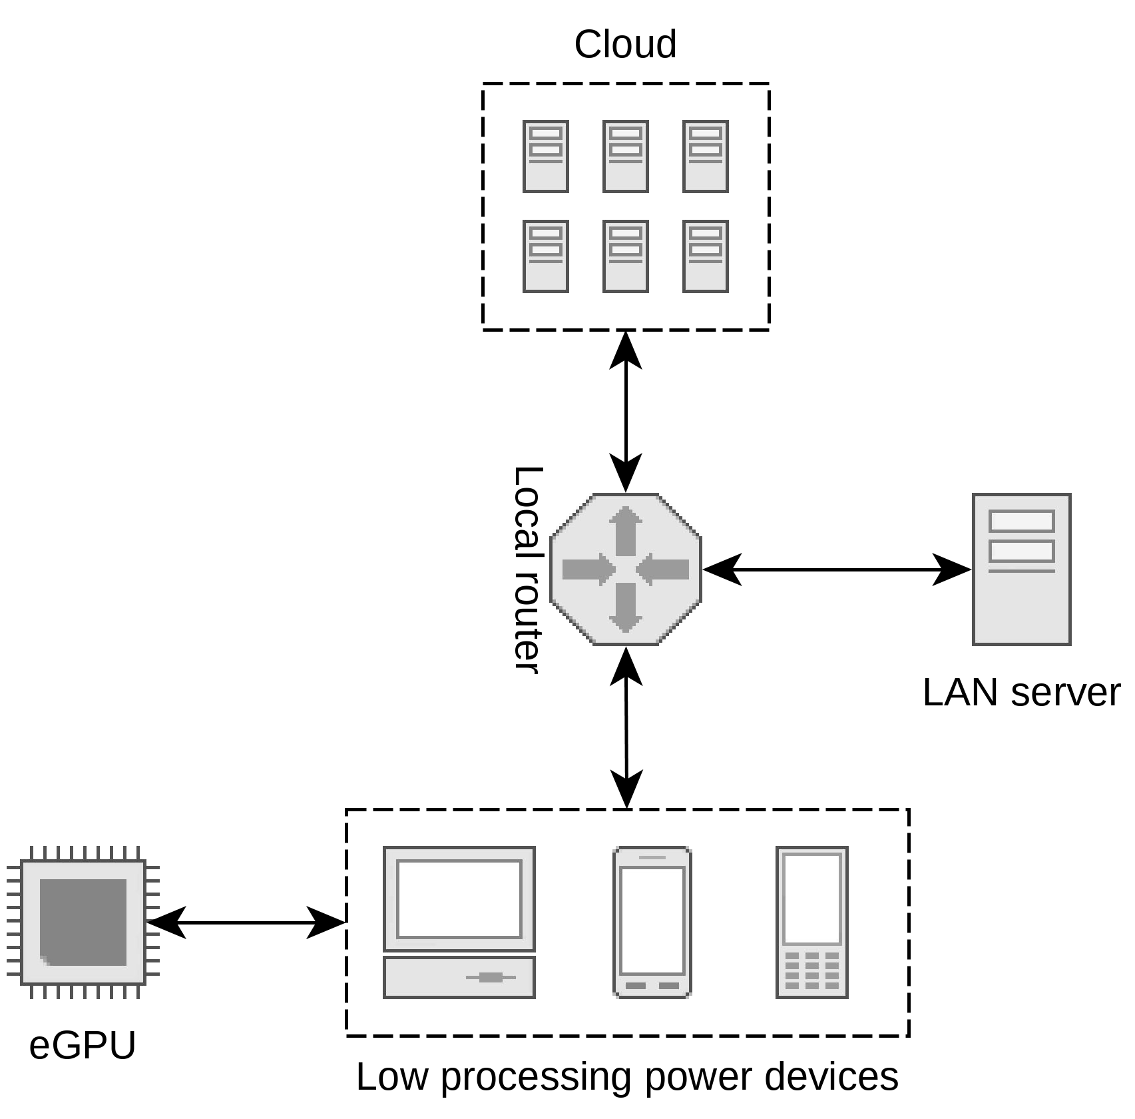

Thank you!
ajevremovic@ieee.org

