The European network 'DIGFORASP' participates in the 'Forensics Europe Expo' in London

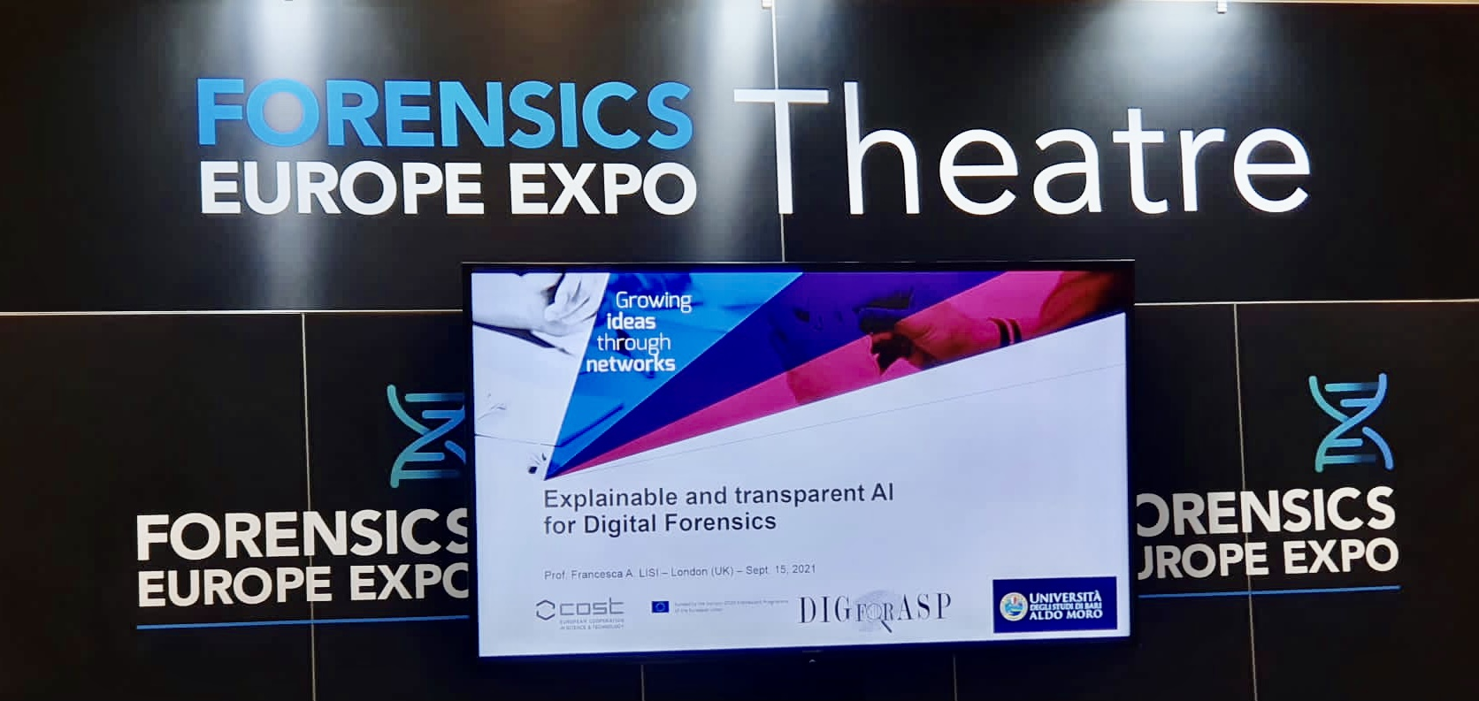
The Forensics Europe Expo has taken place at the ExCeL Conference Center in London on September 14-16, and the European DIGFORASP network has had the opportunity to actively participate, contributing novel perspectives from Artificial Intelligence

Members of the EU-funded network DIGFORASP, coordinated by Professor Jesús Medina of the University of Cádiz, have taken part in Europe’s leading forensics exhibition and conference, the Forensics Europe Expo (FEE). FEE has been held this year in London (UK) from September 14 to September 16, jointly with the Counter-Terror Expo (CTX) and Defence and Security Equipment International (DSEI) events. FEE represents the primary meeting place for forensic solution providers who will be able to explore synergies between these sectors. In addition, it has had a range of innovative exhibitors and a program of educational seminars where a current key topic has been examined: the influence of the COVID-19 pandemic on the future of forensic science.

The main objective of the meeting in London during the FEE event was to show the potential of the scientific research done by DIGFORASP members to the most important companies and personalities in the field of forensic analysis, as well as to strengthen cooperation for the constitution and design of new, more autonomous, and more powerful tools, which can respond to current problems faced by law enforcement professionals across Europe.

DIGFORASP has played an active role in the official programme of the FEE event, with a total of seven talks distributed throughout the three days of the event.
On the first day, Francesca Alessandra Lisi, associate professor at the University of Bari in Italy and manager of the scientific communication of DIGFORASP, has introduced the Action and then focused on the requirements of explainability and transparency for trustworthy AI applications to the forensic domain. Following her introductory talk, there were the contributions from 6 other members of the project: Aleksander Jevremovic, from the University of Informatics and Computing of Serbia, Ivana Stajner-Papua, from the Department of Mathematics and Informatics of the University of Novi Sad in Serbia, Marko Krstic PhD, from the School of Electrical Engineering (ETF) of the University of Belgrade, Raffaele Olivieri, from Grimaldi Group in Italy, Stefania Costantini (Vice-chair of the Action) from the University of L'Aquila in Italy and Zeno Geradts, from the Netherlands Forensic Institute.

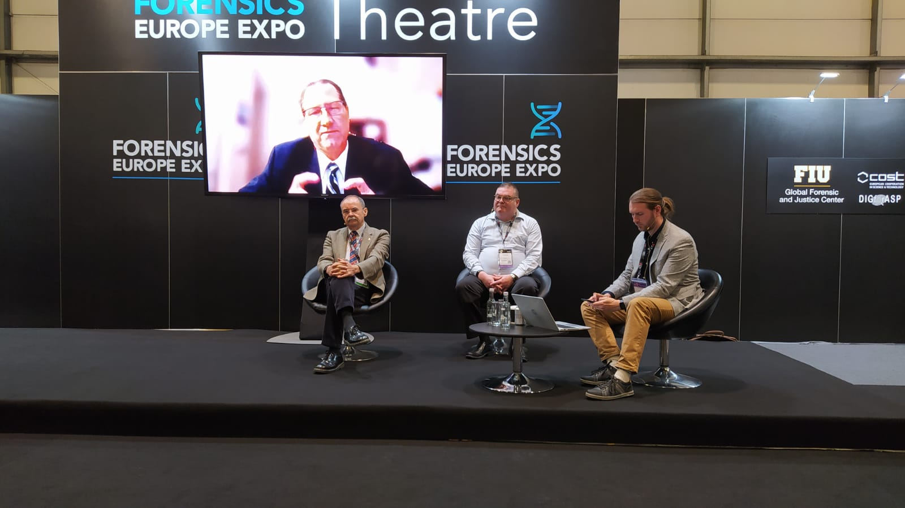
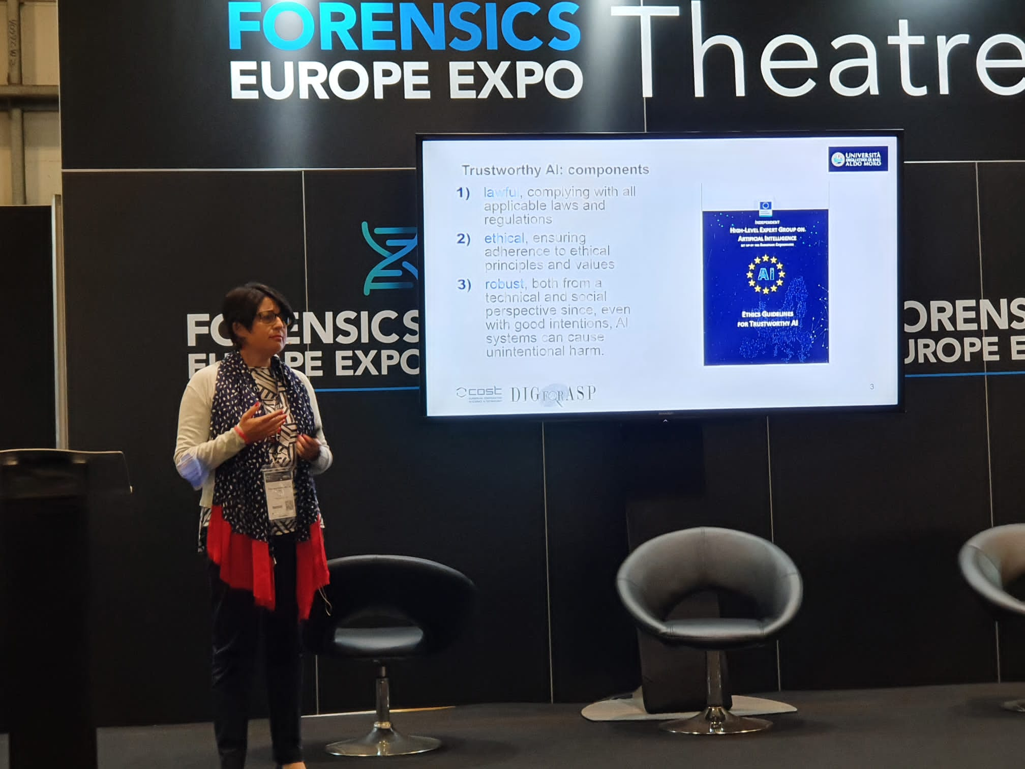
In particular, it is worth to mention the participation of Zeno Geradts in a keynote panel with other experts to discuss emerging technologies for forensic science and criminal justice, and the talk given by Raffaele Olivieri, who has illustrated the importance of digital forensic analysis in the maritime environment and shipping.
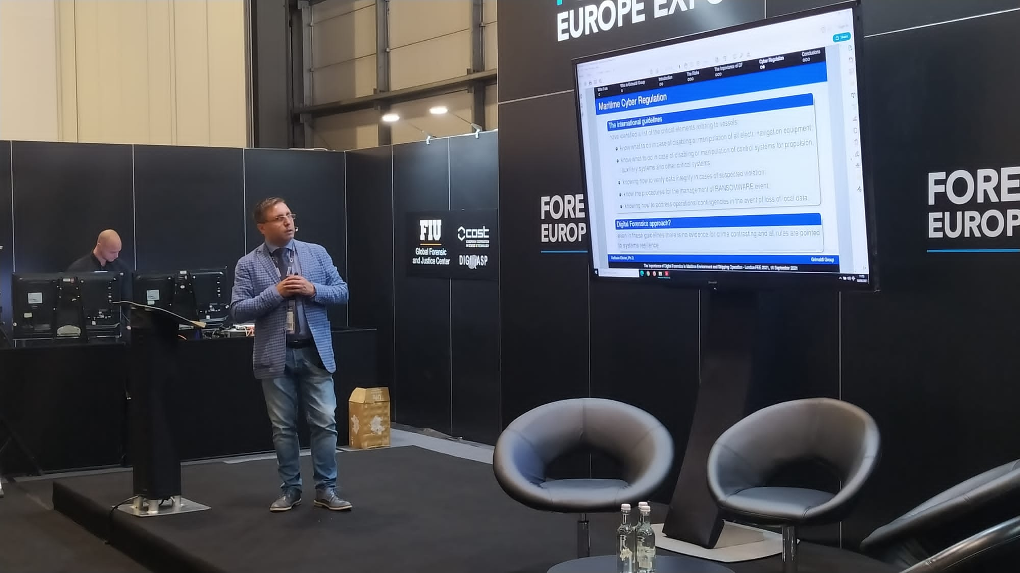

Note for Editors.
The project DigForASP, which stands for “Digital forensics: evidence analysis via intelligent systems and practices” is chaired by Prof. Jesús MEDINA MORENO (University of Cadiz, Spain) and Prof. Stefania COSTANTINI (University of L’Aquila, Italy).
The Project network is financially supported by “Horizon 2020”. It is an initiative born within the European Cooperation Program in Science and Technology (COST), which is the program that aims at strengthening the scientific and technological research in Europe by financing research collaboration networks. DigForASP aims at exploring the potential of the application of Artificial Intelligence (in particular, Automated Reasoning) in the Digital Forensics field, and creating synergies between these fields.
DigForASP is currently the largest intergovernmental network for the coordination of scientific and technological research in Forensics, with the participation of more than 200 specialists and researchers from 36 countries, including 19 ITC (Inclusiveness Target Countries) and Ukraine (Near-Neighbour Country). The activities of DigForASP were started on 10 September 2018 and scheduled to last for four years.

For further info on DigForASP, please visit www.digforasp.uca.es and follow @DigForASP on Twitter.
Contacts: Prof. Francesca Alessandra LISI - Università degli Studi di Bari “Aldo Moro”, Italy - Science Communication Manager of the COST Action DigForASP francesca.lisi@uniba.it

