Epistemic Logic and Theory of Mind for Modelling Group Dynamics of Criminal Organizations

Stefania Costantini

University of L’Aquila, Italy
joint work with Prof. Andrea Formisano and Dr. Valentina Pitoni

FEE 2021

FEE 2021 1 / 16 n
aly joint work with Prof. Andrea Formisano and
ellingDr. VGroupalentinaDynamicsPitoni) of Criminal Organizatio
Stefania Costantini (University of L’Aquila, It Epistemic Logic and Theory of Mind for Mod

Introduction
Our Focus

We intend to model the dynamics of groups of cooperative agents, while enabling Explainability.
A criminal organization can in fact be seen as a group of intelligent agents (i.e., a Multi-Agent System, or MAS) aiming to cooperatively reach common objectives.
We intend to build a system which is able to understand if and how such a group can reach its objectives. Explainability is a crucial factor, allowing investigators to understand the system’s conclusions.

FEE 2021 2 / 16 n
aly joint work with Prof. Andrea Formisano and
ellingDr. VGroupalentinaDynamicsPitoni) of Criminal Organizatio
Stefania Costantini (University of L’Aquila, It Epistemic Logic and Theory of Mind for Mod

Introduction
Our Methodology

To build such a system, we propose a particular epistemic logical framework.
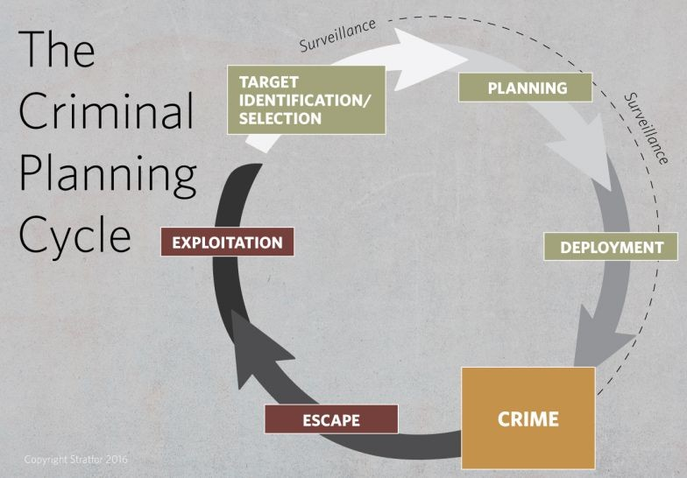
We highlight the concepts of: cost of actions, and budget which an agent (or the entire group) must have available in order to perform an action; capabilities and preferences on performing each action.
We drew inspiration from of Theory of Mind, Social Intelligence and Self-aware systems.

FEE 2021 3 / 16 n
aly joint work with Prof. Andrea Formisano and
ellingDr. VGroupalentinaDynamicsPitoni) of Criminal Organizatio
Stefania Costantini (University of L’Aquila, It Epistemic Logic and Theory of Mind for Mod

Introduction
Theory of Mind (ToM)

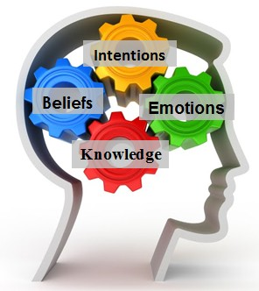
Theory of Mind refers to the cognitive capacity to attribute mental states to self and others, i.e., “commonsense psychology”, “na¨ıve psychology”, “folk psychology”, “mindreading” and “mentalizing”.
In cognitive science, the question is: how do people execute this cognitive capacity? How do they, or their cognitive systems, can form beliefs or judgments about others’ mental states, states that aren’t directly observable?
There are logics, among which ours, that try to emulate aspects of ToM.

FEE 2021 4 / 16 n
aly joint work with Prof. Andrea Formisano and
ellingDr. VGroupalentinaDynamicsPitoni) of Criminal Organizatio
Stefania Costantini (University of L’Aquila, It Epistemic Logic and Theory of Mind for Mod

Introduction
Theory of Mind (ToM)

In fact, in order to be able to cooperate, agents must be (at least partly) aware of other agents’ Mental State, i.e, what they believe and know, what are their intentions and their current plans.
Agents in a group must thus devise mechanisms to make the others aware of their mental state, and there must be some mechanism to build plans according to each agent’s capabilities, resources and preferences.
“Traditional” BDI logic must be extended.

FEE 2021 5 / 16 n
aly joint work with Prof. Andrea Formisano and
ellingDr. VGroupalentinaDynamicsPitoni) of Criminal Organizatio
Stefania Costantini (University of L’Aquila, It Epistemic Logic and Theory of Mind for Mod

Introduction
Motivation

Why Epistemic Logic: it has proven to be a good tool to express the semantics underlying (aspects of) agent-oriented programming languages, as it allows properties of the behaviour of an agent or a group of agents to be expressed and proved.
K₁(human(X) mortal(X))
→
K₁(human(me))

B₁(night)
B₁(night → thieves−risk)
B₂(thieves−risk → activate−alarm)
B₃(rich(2) night attempt theft)
∧ → −
Agents belonging to the same group (e.g., 1 and 2) may share their conclusions, so agent 1 concludes that there is a risk, and agent 2 takes countermeasures.
FEE 2021 6 / 16 n
aly joint work with Prof. Andrea Formisano and
ellingDr. VGroupalentinaDynamicsPitoni) of Criminal Organizatio
Stefania Costantini (University of L’Aquila, It Epistemic Logic and Theory of Mind for Mod

Introduction
Our proposal:
a Bridge between Theory and Practice

We introduce the representation of physical actions that agents can do, actually do, or have done: why explicit representation of physical actions? because in principle an agent can explain to a user what it does and has done, and reason about its past actions.

We introduce the cost of actions, and the possibility to define policies to share such cost among members of a group.

We introduce the specification of what an agent can do or prefers to do, to model single agents’ and group’s capabilities.

FEE 2021 7 / 16 n
aly joint work with Prof. Andrea Formisano and
ellingDr. VGroupalentinaDynamicsPitoni) of Criminal Organizatio
Stefania Costantini (University of L’Aquila, It Epistemic Logic and Theory of Mind for Mod

Introduction
Characterization

The proposed logic L-DINF consists of a static component and a dynamic one:
the static component, called L-INF, is a logic of explicit beliefs and background knowledge (used to represent the“long-term memory” of the agent);
the dynamic component, called L-DINF, extends the static one with dynamic operators capturing the consequences of the agents’ inferential operations on perceptions, producing new explicit beliefs (used to represent the “short-term memory” of the agent).
To provide the semantics to our new logic, we extended a standard neighborhood semantics (reachable worlds model knowledge, while the neighboring worlds models beliefs). L-DINF is: sound w.r.t. its axiomatization; strongly complete, using a canonical model argument.
FEE 2021 8 / 16 n
aly joint work with Prof. Andrea Formisano and
ellingDr. VGroupalentinaDynamicsPitoni) of Criminal Organizatio
Stefania Costantini (University of L’Aquila, It Epistemic Logic and Theory of Mind for Mod

Introduction
Cost of Physical Actions

The execution of an action may involve a cost.
So, to execute actions, an agent must possess the necessary budget.
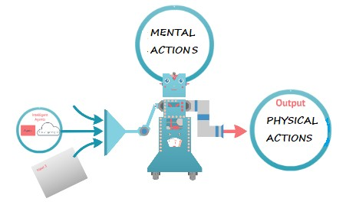
When an agent belongs to a group, if that agent does not have enough budget to perform an intended action, it may be supported by its group.
The cost will be shared according to an agreed-upon policy.
cost is not necessarily money, rather, it may represent any resource required.

FEE 2021 9 / 16 n
aly joint work with Prof. Andrea Formisano and
ellingDr. VGroupalentinaDynamicsPitoni) of Criminal Organizatio
Stefania Costantini (University of L’Aquila, It Epistemic Logic and Theory of Mind for Mod

Example
Example

Consider a group of 3 criminals, who intend to rob in a bank vault.
Suppose that:
agent 1 is able to dig a tunnel to the vault, but he needs a small excavator;
agent 2 is able to open the security door, by means of suitable hardware tools;
agent 3 will go to buy the needed tools, and will act as a guard outside the bank; however, he has not enough money, so he needs a loan by the others.

FEE 2021 10 / 16 n
aly joint work with Prof. Andrea Formisano and
ellingDr. VGroupalentinaDynamicsPitoni) of Criminal Organizatio
Stefania Costantini (University of L’Aquila, It Epistemic Logic and Theory of Mind for Mod

Example
Example (cont’d)

Cooperative behaviour: within a group of agents G, an action is performed at the following conditions:
at least one agent A in G is able to perform it;
either A has enough budget itself, or, if not, the group can share the cost;
execution of an action is assigned to the best-willing agent;
which means, given the established policy, that the amount to lend is within each agent’s available budget.

FEE 2021 11 / 16 n
aly joint work with Prof. Andrea Formisano and
ellingDr. VGroupalentinaDynamicsPitoni) of Criminal Organizatio
Stefania Costantini (University of L’Aquila, It Epistemic Logic and Theory of Mind for Mod

Example
Example (cont’d)

Assume that, initially, the agents have the following budgets:
B(1, w₁) = 11, B(2, w₁) = 21, B(3, w₁) = 20
The knowledge base of each agent i contains the following rule, that specifies how to reach the intended goal in terms of actions to perform:
B_{i}(intend_{G} (rob bank ) intend_{G} (buy -material ) intend_{G} (dig -hole) intend_{G} (break -in-door ))
∧
∧
→
A suitable axiom of our logic states that group’s intentions (intend_{G}) become intentions of each of its members.

FEE 2021 12 / 16 n
aly joint work with Prof. Andrea Formisano and
ellingDr. VGroupalentinaDynamicsPitoni) of Criminal Organizatio
Stefania Costantini (University of L’Aquila, It Epistemic Logic and Theory of Mind for Mod

Example
Example (cont’d)

An action can be done by a group and then is done by a group if it can be done and is done by any of the participating agents.
B_{i}(intend_{G} (buy -material )) →
have−budget_{G} (41 )∧ can do_{G} (buy material )
— ∧
-
do_{G} (buy -material ))
Assume that agent 3, who is basically unable to achieve complex tasks, is willing to go and buy material. But, he has a budget of 11 and the material costs, say, 41.
The other agents share the cost, so, agent 3 will borrow the necessary sum from the group in equal parts given availability: he can give 11, and agents 1 and 2 will give 20 each. So, the overall goal can be achieved.

FEE 2021 13 / 16 n
aly joint work with Prof. Andrea Formisano and
ellingDr. VGroupalentinaDynamicsPitoni) of Criminal Organizatio
Stefania Costantini (University of L’Aquila, It Epistemic Logic and Theory of Mind for Mod

Conclusions
Conclusions

The proposed logic L-DINF defines (some aspects of) the semantics of MAS, by introducing physical actions’ executability, actions’ past and present execution, actions’ cost, budgets and policies for cost-sharing, capabilities and preferences, concerning a group of cooperative agents.
This allows in particular to formalize the structure of criminal organizations, and to understand via logical inference what such organizations might attempt or achieve in practice.
Explainability is “by design”, as logical proofs can easily be transposed into natural language.
An implementation is under way in the agent-oriented logic language DALI, developed by our research group (https://github.com/AAAI-DISIM-UnivAQ/DALI)

FEE 2021 14 / 16 n
aly joint work with Prof. Andrea Formisano and
ellingDr. VGroupalentinaDynamicsPitoni) of Criminal Organizatio
Stefania Costantini (University of L’Aquila, It Epistemic Logic and Theory of Mind for Mod

Conclusions
Multi-Agent Modelling

Each agent in the logic theory will be simulated by a DALI agent.
Capabilities and interactions can be modeled in DALI.
Since Epistemic Logics are complex, the representation is approximate.
However, the capabilities of a criminal organization to achieve its goals can still be properly explored.
So, this approach can constitute a good tool to aid investigators.

FEE 2021 15 / 16 n
aly joint work with Prof. Andrea Formisano and
ellingDr. VGroupalentinaDynamicsPitoni) of Criminal Organizatio
Stefania Costantini (University of L’Aquila, It Epistemic Logic and Theory of Mind for Mod

Conclusions

Thank you for your attention!
Questions are welcome

at email stefania.costantini@univaq.it

FEE 2021 16 / 16 n
aly joint work with Prof. Andrea Formisano and
ellingDr. VGroupalentinaDynamicsPitoni) of Criminal Organizatio
Stefania Costantini (University of L’Aquila, It Epistemic Logic and Theory of Mind for Mod

