MT WG AND ENFSI MEETING DIGFORASP COST ACTION 17124
School of Computer Science and Engineering.
Málaga, Spain September 27th 29th

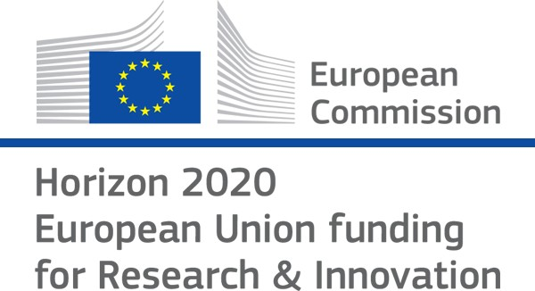

MONDAY 27th
10:00 13:00 | Participants arrive in Málaga
13:00 13:30 | Welcome: gathering of participants in the hall of the University
13:30 14:30 | Working lunch in E.T.S.I.
14:30 14:45 | Opening and Report on Working Groups
14:45 16:45 | Study session 1 (mini-thematics working groups)
16:45 17:30 | Coffe Break
17:30 18:30 | Study session 2 (mini-thematics working groups)

TUESDAY 28th
9:30 10:40 | Workshop. Session 1
 | 9:30 09:50 | Challenges and achievements DigForASP  Jess Medina. Action Chair DigForASP, University of Cádiz
 | 09:50 10:15 | The ENFSI Forensic IT working group  Zeno Geradts. Chair Forensic Data Science University of Amsterdam
 | 10:15 10:40 | Leveraging Machine Learning to Malware Analysis  Suguru Horimoto. National Police Agency, Japan
10:40 11:05 | Coffe Break
11:05 12:50 | Workshop. Session 2
 | 11:05 11:25 | Epistemic Logic and Theory of Mind for Modelling Group Dynamics of Criminal Organizations  Stefania Costantini. University of L'Aquila
 | 11:25 11:50 | The development of an artificial neural network for forensic password recovery  Erik Krupicka. BKA Bundeskriminalamt KT51 -Bild-
 | 11:30 11:50 | Artificial Intelligence and Law Enforcement: Main applications and Impact on Fundamental Rights.  José María Castillo-Secilla. Cuerpo Nacional de Policía. Spain
 | 11:50 12:10 | Improvements and challenges in MRZ reading  José Manuel Rodríguez-Jiménez. Policía Local, Spain
 | 12:30 12:50 | To be announced  Raffaele Olivieri. Security Intelligence and Law Enforcement
12:50 13:30 | Round Table
13:30 15:00 | Working lunch at E.T.S.I
15:00 16:30 | Study session 3 (mini-thematics working groups)
16:30 17:00 | Coffe Break
17:00 18:00 | Study session 4 (mini-thematics working groups)

WEDNESDAY 29th
10:00 11:20 | Workshop. Session 3
 | 10:00 10:20 | Automatic Image Analysis  Philip Engstrom. Swedish National Forensic Center
 | 10:20 10:40 | Advances in forgery detection of driving licences using truth- fulness degrees  Jos Manuel Rodríguez-Jiménez. Policía Local, Spain
 | 10:40 11:00 | To be announced  Kim de Bie. Forensic Big Data Analysis Netherlands Forensic Institute
 | 11:00 11:20 | To be announced  Pedro Cabalar. Universidad de La Coruña. Spain
11:20 11:50 | Coffe Break
11:50 13:00 | Workshop. Session 4
 | 11:50 12:10 | Digital Forensic Data Clustering  Piotr A. Kowalski. AGH University of Science and Technology. Krakow, Poland.
 | 12:10 12:40 | DigForASP + Ethics = DigForEthics: recent and forthcoming activities  Chiara Gallese, Viviana Mascardi.
 | 12:40 13:00 | Trustworthy AI in High Education  Juan Carlos Nieves. University of Umea
13:00 13:30 | Round Table
13:30 14:30 | Closing

