The European network 'DigForASP' chooses Cadiz as a destination to put the finishing touch.
The DIGital FORensics COST Action: Analysis of evidence through intelligent systems and practices (DigForASP), which is coordinated by the Professor of Mathematics at the University of Cadiz, Jesús Medina, held its 9th Working Group Meeting in Cadiz, as a closure of the COST Action CA17124 after the EU funding period (from 2018 to 2023).
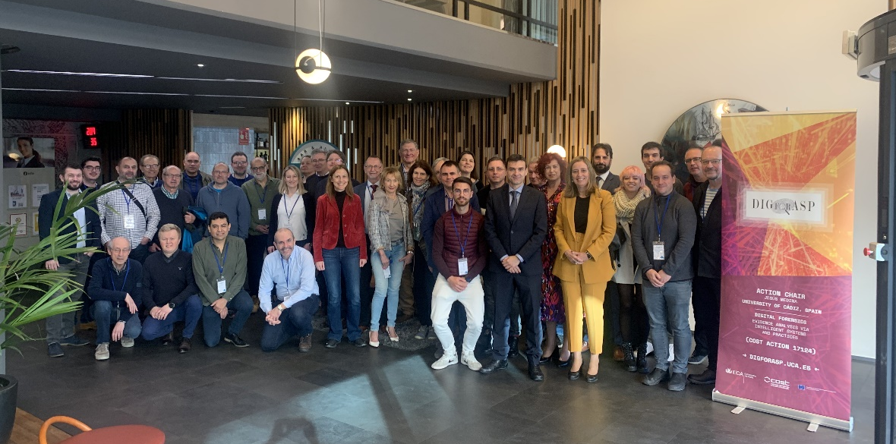

The program, held from March 1-3, included collaborative sessions and lectures by academic researchers. Among the main objectives of this meeting are: to present the latest developments of the Action, to evaluate the current status of the Action and the fulfillment of its objectives, to study and propose to the Action the next steps and new challenges in relation to the DIGital FORensics Network after the end of the COST funding.
Vice-Rector for Science and Technology Policy of the University of Cadiz (Spain), Mª Jesús Mosquera, together with the Professor Jesús Medina (Action Chair), and the Professor Stefania Costantini (Action Vice-Chair) of the University of L´Aquila (Italy) opened the meeting and welcomed the participants.
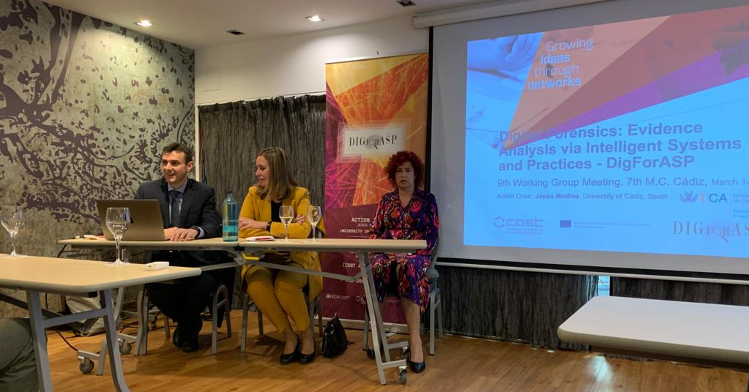

A workshop dedicated to the current challenges and achievements of the network was held, with special mention to the plenary sessions given by Pedro Cabalar, from the Department of Computer Science and Technologies of the University of Coruña (Spain), and Óscar Cordón, from the Department of Computer Science and Artificial Intelligence of the University of Granada (Spain). In this new Meeting of Working Groups, the leaders of each one of them have presented the current status of each group. The three-day program included parallel work sessions and lectures given by academic researchers, specialists from more than 20 different countries.

The DigForASP project is supported by the European Cooperation in Science and Technology Program (COST), funded by the Horizon 2020 EU Framework Program, which seeks to strengthen scientific and technical research in Europe by financing the establishment of collaborative networks between researchers. This project, coordinated by Prof. Jesús Medina from the University of Cadiz, Spain, is the largest European intergovernmental network for the coordination of scientific and technical research in the field of Digital Forensics, with the participation of more than 200 specialists and researchers from 36 countries.
Since its approval in April 2018, this project led by UCA has created a scientific network that integrates universities from Albania, Germany, Austria, Belgium, Bosnia and Herzegovina, Bulgaria, Croatia, Cyprus, Czech Republic, Denmark, Slovakia, Slovenia, Spain, Finland, France, Greece, Holland, Hungary, Ireland, Israel; Italy, Latvia, Malta, North Macedonia, Montenegro, Norway, Poland, Portugal, Romania, Serbia, Sweden, Switzerland, Turkey, United Kingdom and Ukraine.

