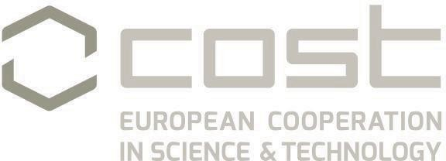

INFO DAY
Digital forensics: evidence analysis via intelligent systems and practices

30 January 2023
Faculty of Electrical and Electronic Engineering, University of Montenegro

Agenda:

9:45 | Registration
10:00 | Welcome  PRESENTATIONS I
10:15 | Prof Andreja Tepavcevic – Action representative (MC member and WG6 Leader), Faculty of Sciencies, Novi Sad, Serbia
10:30 | Prof Vladimir Bozovic – President at University of Montenegro- “Opening of Regional Center for Cyber Security at University of Montenegro”
10:45 | Miss Milena Milonjic – CNC- COST National Coordinator, “Involvement and participation of Montenegro in COST Actions”
11:00 | PhD Miograd Mihaljevic – Mathematical Institute at Serbian Academy of Sciencies and Arts, “Blockchain Technology for Digital Forensics”
11:25 | Msc Tomislav Vardar – CSO & Head of Corporatore Security Erste&Steiermaerkische bank d.d., “Building a Cyber Security Culture”, Croatia
11:50 | Coffee break
12:30 | PRESENTATIONS II  MSc Jaksa Backovic – Chief of Unit for Combating Cyber Crime at Ministry of Interior of Montenegro, “BEC frauds in Montenegro”
 | Prof Ivana Stajner Papuga – Action representative, University of Novid Sad, “Topic-to be defined”
 | Prof. dr Vesna Dimitrova – North Macedonia, Faculty of Computer Science and Engineering
 | Forensics Center Podgorica – representative to be chosen to speak
13:30 | Lunch break, Restaurant Desetka, at the 1º floor of Faculty of Electrical Engineering
14:30 | Wrap-up discussion, ideas for activities
15:30 | End of meeting
The goal of this Info Day is to extend the network of researchers, security forces and members of other relevant institutions from Montenegro and the region in order to explore the potential of the application of Artificial Intelligence and Automated Reasoning in the Digital Forensics field, which is the major challenge of the COST Action 17124 - DigForASP. Therefore, among others, representatives from the Ministry of Interior of North Macedonia, relevant stakeholders, private companies and universities will be part of this event.
Web site: https://digforasp.uca.es/ Follow us on Twitter

